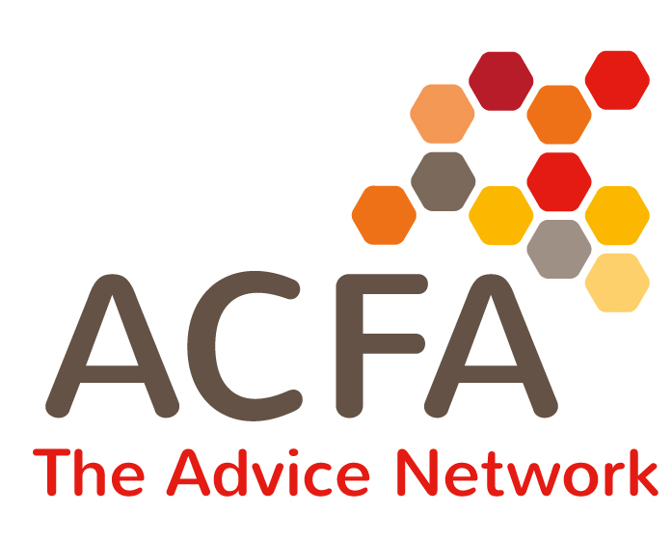
Training Programme – Booking Form
Just three simple steps:
- Please specify the number of places required on each course
- Complete the delegate detail section
- Email completed form with an order number to: admin.swat@gmail.com

By completing this form you agree to our booking conditions and cancellation charges outlined below.
If you cancel giving us more than 4 weeks written notice, we will charge 50% of the course fee to cover administration costs. With less than 4 weeks notice, the full course fee will be charged.

No. of places | Course Title / Date | Course Costs (per person)  - select correct category for your organisation
£60 – Half Day – ACFA members

£75 – Half Day – Other voluntary &
Community organisations

£105 – Half Day – Local Authorities and Housing Associations

£125 – Half Day – Private Organisations

£100 – Full Day – ACFA members

£120 – Full Day - Other voluntary &
Community organisations

£150 – Full Day – Local Authorities and Housing Associations
£180 – Full Day – Private Organisations

Delegate Name and Email Address | Course Attending
1.
2.
3.

Organisation: |  | Tel No: |  | ACFA Member? Yes/No
Contact Name and Email
Invoice Name and Address
Please note if you have any dietary
or access requirements.

Thank you for your booking – delegates will be sent a reminder a few days before the course.

